Bangladesh Medical Association (BMA)
List of Life Member-29
47. BMA Netrakona Branch

Sl No | Voter No | Voter Details
1 | Voter No  LM-4700001  No Image | DR. MD. KAMAL UDDIN  F/Name: Md. Altaf Ali Sarker  M/Name:  BM & DC Reg. No:  NID:  Cell:  Address: Court Road  Netrokona  Blood Group:
2 | Voter No  LM-4700002  No Image | DR. ABDUS SATTAR  F/Name: Late Khoda Newaj  M/Name:  BM & DC Reg. No:  NID:  Cell:  Address: Shajhan Medical Hall  Tari Bazar  Netrokona  Blood Group:
3 | Voter No  LM-4700003  No Image | DR. RANJAN KUMAR KARMOKER  F/Name: Kalipada Karmoker  M/Name:  BM & DC Reg. No:  NID:  Cell:  Address: Medical Officer  Adhunik Sadar Hospital  Netrokona  Blood Group:
4 | Voter No  LM-4700004  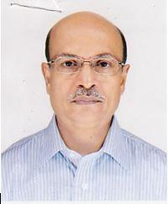 | DR. RATHINDRA KUMAR SARMA  F/Name:  M/Name:  BM & DC Reg. No:  NID:  Cell:  Address: New Town  P.o.-Netrokona  Netrokona  Blood Group:
5 | Voter No  LM-4700005  No Image | DR. MD. ABUL BASET  F/Name:  M/Name:  BM & DC Reg. No:  NID:  Cell:  Address: Civil Surgeon  Netrokona  Blood Group:
6 | Voter No  LM-4700006  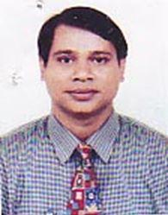 | DR. DILIP KUMAR DEBNATH  F/Name: Satyendra Lal Debnath  M/Name: Maya Rani Deby  BM & DC Reg. No: 22799  NID:  Cell: 01712-042779  Address: KoLM-a Kanda  Thana Health Complex, Netrokona.  Blood Group:
7 | Voter No  LM-4700007  No Image | DR. A.K.M RAFIQUL ISLAM KHAN  F/Name: Md. Rajab Ali Khan  M/Name:  BM & DC Reg. No:  NID:  Cell:  Address: N/A  Blood Group:
8 | Voter No  LM-4700008  No Image | DR. MD. SAIFUL HOQUE TALUKDER  F/Name:  M/Name:  BM & DC Reg. No:  NID:  Cell:  Address:  Blood Group:  TRANSFERED to BMA Dhaka City  LM-1405543
9 | Voter No  LM-4700009  No Image | DR. MD. NURUL AMIN AKANDA  F/Name:  M/Name:  BM & DC Reg. No:  NID:  Cell:  Address:  Blood Group:  TRANSFERED to BMA Dhaka City  LM-1405543
10 | Voter No  LM-4700010  No Image | DR. A.K.M. MOQSUDUL HASAN  F/Name:  M/Name:  BM & DC Reg. No:  NID:  Cell:  Address:  Blood Group:  TRANSFERED to BMA Dhaka City  LM-1405543
11 | Voter No  LM-4700011  No Image | DR. MD. AFTAB UDDIN  F/Name: Afzal Uddin Ahmed  M/Name:  BM & DC Reg. No:  NID:  Cell:  Address: Thana Health Complex  Planing Officer,Mohangonj  Netrokona  Blood Group:
12 | Voter No  LM-4700012  No Image | DR. MD. SARIFUL ISLAM BHUIYAN  F/Name:  M/Name:  BM & DC Reg. No:  NID:  Cell:  Address: Medical Officer  Sadar Hospital  Netrokona  Blood Group:
13 | Voter No  LM-4700013  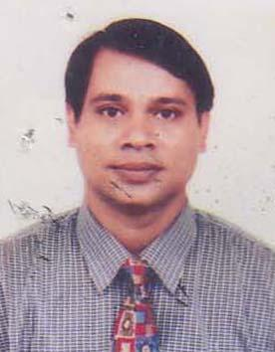 | DR. DIPAK KUMAR NAG  F/Name: Jagadish Chandra Nag  M/Name: Priya Chandra Nag  BM & DC Reg. No: 19560  NID: 7227407245331  Cell: 01711332231  Address: Asst. Prof. Ophthalmology National Institute Of Ophthalmology & Hospital, Dhaka.  Blood Group: B+
14 | Voter No  LM-4700014  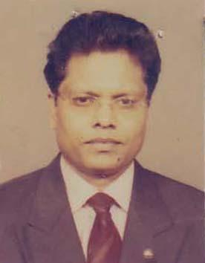 | DR. PALASH MAJUMDER  F/Name: Tarapada Majumder  M/Name: Sobi Majumder  BM & DC Reg. No: 25545  NID: 7227402107830  Cell: 01711268251  Address: Satpai, Kali Bari Road, Netrokona.  Blood Group: O+
15 | Voter No  LM-4700015 | dR. JAWHAR LAL SINGHA  F/Name:  M/Name:  BM & DC Reg. No: 24369  NID:  Cell: 01552320086  Address: Room 1, DAK- Bangla Bhaban Durgapur, Netrokona.  Blood Group: A+  TRANSFERED to BMA Dhaka City  LM-1405543
16 | Voter No  LM-4700016 | dR. ZAHIRUL HASAN KHAN  F/Name: Late Abdul Mannan Khan  M/Name: Jahanara Akter Khanom  BM & DC Reg. No: 45111  NID: 2697557395779  Cell: 01712130762  Address: MO, Upazilla Health Complex, Kalmakanda, Netrokona.  Blood Group: B+
17 | Voter No  LM-4700017  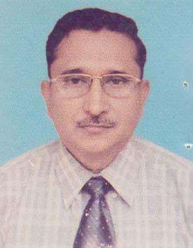 | DR. JYOTIRMAY AICH  F/Name: Late Satish Chandra Aich  M/Name: Late Shashi Bala Aich  BM & DC Reg. No: 6972  NID: 7727303112894  Cell: 01712277006  Address: 59/B, Rambabu Road, Mymensingh.  Blood Group: O+
18 | Voter No  LM-4700018  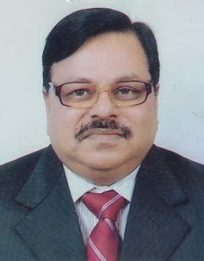 | dR. SHAHID UDDIN AHMED  F/Name: Shahab Uddin Ahmed  M/Name: Jahnara Ahmed  BM & DC Reg. No: 11866  NID: 7227406132431  Cell: 01712135270  Address: Civil Surgeon Office, Netrokona.  Blood Group: B+
19 | Voter No  LM-4700019  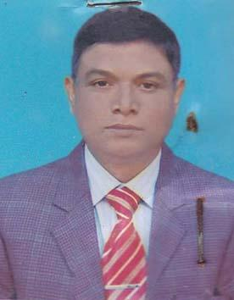 | DR. BIJAN KANTI SARKER  F/Name: Late Birendra Kumar Sarker  M/Name: Late Amya Prava Sarker  BM & DC Reg. No: 14652  NID: 7227407136838  Cell: 01712006814  Address: Deputy Civil Surgeon Office, Netrokona.  Blood Group: O+
20 | Voter No  LM-4700020 | DR. MRINAL KANTI PANDIT  F/Name: Late. Dr. Naresh Chandra Pandit  M/Name: Late. Narayani Pandit  BM & DC Reg. No: 13208  NID: 6125210124301  Cell: 01711071812  Address: UH&FPO, Upazilla Health Complex, Kalmakanda, Netrokona  Blood Group: B+
21 | Voter No  LM-4700021  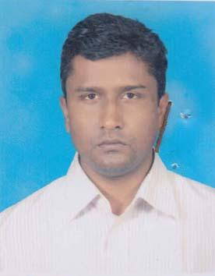 | DR. RAJESH KUMAR DAS  F/Name: Rasbehari Das  M/Name: Gayetri Das  BM & DC Reg. No: 29370  NID: 7227407138736  Cell: 01711060835  Address: Mukterpara, Netrokona.  Blood Group: O+
22 | Voter No  LM-4700022  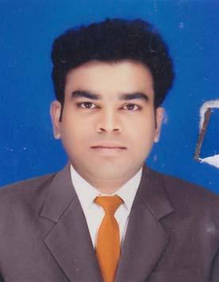 | DR. AHSAN KABIR RIAD  F/Name: Md. Matior Rahman  M/Name: Mosammad Sanoara Begum  BM & DC Reg. No: 40229  NID:  Cell: 01716228546  Address: 8/A, STUIF Quarter, Charpara, Mymensingh Medical College Hospital Mymensingh.  Blood Group: B+
23 | Voter No  LM-4700023  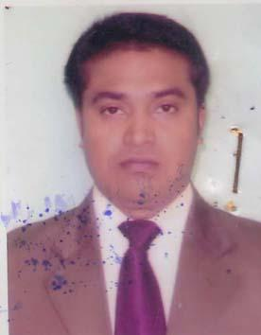 | DR. MD. HABIBUR RAHMAN  F/Name: Late Mokbul Hossain Ahmed  M/Name: Mrs. Zayeda Akhter  BM & DC Reg. No: 42991  NID:  Cell: 01913812016  Address: EMO, Adhunik Sadar Hospital, Netrokona.  Blood Group: A+
24 | Voter No  LM-4700024  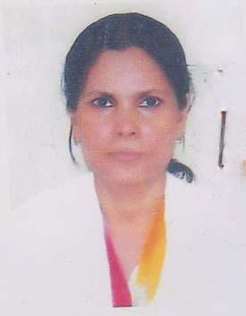 | DR. PAPIYA MAJUMDER  F/Name: Tejendra Kumar Majumder  M/Name: Makul Rani Majumder  BM & DC Reg. No: 26307  NID: 2692620641488  Cell: 01716522981  Address: Medical Officer ( Clinic), MCWC, Netrokona.  Blood Group: O+
25 | Voter No  LM-4700025 | DR. PRASANTA SARKER  F/Name: Bhajan Chandra Sarker  M/Name: Rina Rani Sarker  BM & DC Reg. No: 46975  NID: 9196203131304  Cell: 01731247074  Address: 275, Kalibari Road, Joynagor  Netrakona  Blood Group: O+
26 | Voter No  LM-4700026  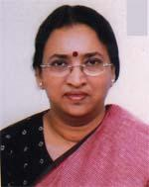 | Dr. Debjani Sarkar  F/Name: Late. Ram Sarker  M/Name: Sumitra Sarkar  BM & DC Reg. No: 14816  NID: 6125207153456  Cell: 01717315316  Address: Teribazar, Netrakona  Blood Group: O+
27 | Voter No  LM-4700027  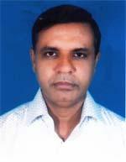 | DR. SANDIP KUMAR BHATTACHARJEE  F/Name: Late. Nripendra Chandra Bhattacharjee  M/Name: Late. Pritikana Bhattacharjee  BM & DC Reg. No: 21144  NID: 7227402107493  Cell: 01718535859  Address: Satiai, (Gara Road) Netrakona  Blood Group: B+
28 | Voter No  LM-4700028  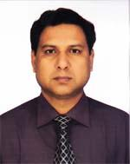 | DR. MD. MAKSUDUR RAHMAN  F/Name: Late. Abul Kashem  M/Name: Mrs. Ayesha Khatun  BM & DC Reg. No: 30083  NID: 6127205168381  Cell: 01711119081  Address: Central Hospital Mukterpara, Netrakona  Blood Group: B+
29 | Voter No  LM-4700029  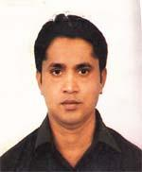 | DR. TITU MOHON SAHA  F/Name: Krishna Mohon Saha  M/Name: Late Usha Rani Saha  BM & DC Reg. No: 38777  NID: 7227405129224  Cell: 01714088170  Address: Mymensing Medical College Hospital Dept. Of Anaesthesiology & ICU Mymensingh.  Blood Group: O+

